Red Team
Marco Rodriguez Gomez https://github.com/mrodriguezLearning/csd-310
Sean Summers
Kris Kleiner
Jeffrey Crossdale
Jeff Victorino
Milestone 1, 2 and 3
CSD310 - Database Development - Willson Financial Case Study Project
  - Willson Financial case study
Milestone #1
Business Rules and Assumptions
Explicit Rules:
- Client Tracking: The system must record when clients are added to track growth over specific periods, such as the past six months. Each client must have a unique ID.
- Asset Management: The system must store the amount of assets (in currency) for each client to allow for calculations like the company-wide average.
- Transaction Logging: The database must track individual transactions per client to identify clients with high transaction volumes (e.g., more than 10 a month). Each transaction must have a unique transaction ID.
- Billing: Each client must be associated with a billing structure. Billing structures must have unique structure IDs. Billing records will be generated once per client per calendar month.
- Appointments: The system needs to handle client appointments, which are managed by the office employee. Each appointment must have a unique appointment ID.
- Compliance: Client records must be accessible only by employees. Assets can only be managed by Advisors. Appointment and transaction history must be accessible to a client, but only their own history. All records must be kept in accordance with law requirements.
Assumptions:
- Advisors and Clients: Each client is assigned to a specific financial advisor (Employees either Jake or Ned). An advisor can have multiple clients, but a client has only one primary advisor.
- Employee Roles: The system should track all employees (Jake, Ned, Phoenix, and June) and their respective roles or titles (e.g., Advisor, Office Employee, Compliance Manager).
- Transactions: A transaction belongs to one and only one client. A client can have zero or many transactions.
- Appointments: An appointment involves exactly one client and one employee. A client can have multiple appointments over time.
- Billing: Several options for proposed new billing structures.

ERD
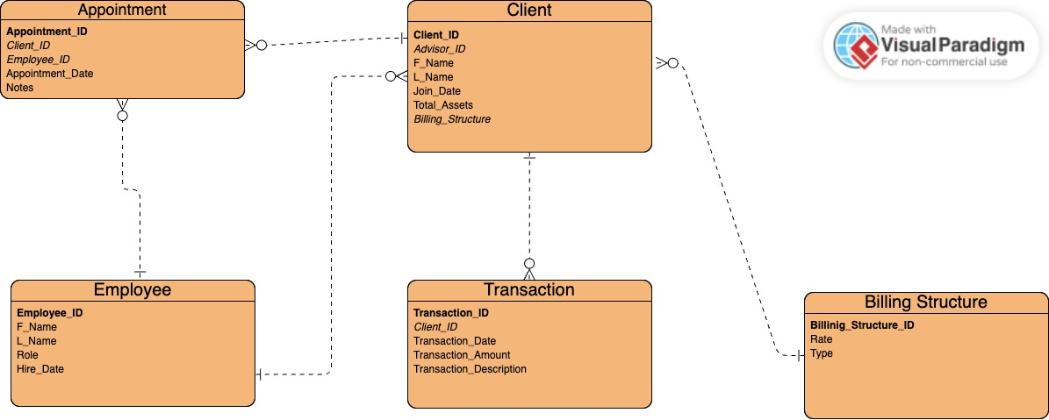
Milestone #2
Revised ERD
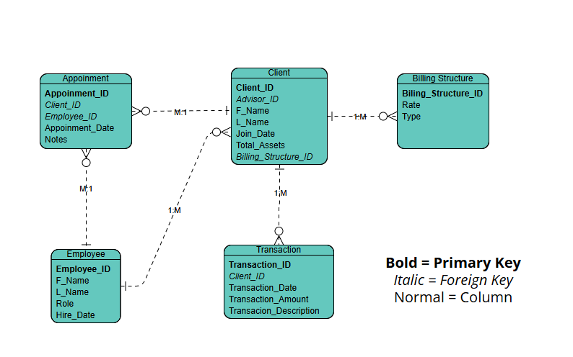

3NF:
- No Partial Dependencies: Every table has a single-column primary key, so all non-key attributes depend on the entire key.
- No Transitive Dependencies: By moving rate and type out of the Client table and into Billing Structure, we ensure that rate depends on Billing_Structure_ID, not on Client_ID.
- Normalization of Roles: While role is currently a string in the Employee table, in a larger system, you could move that to a Role lookup table to further normalize if different employees shared identical role-based permissions.
Screenshots
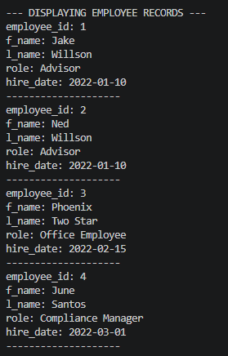
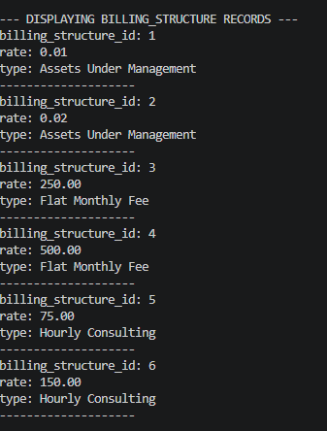
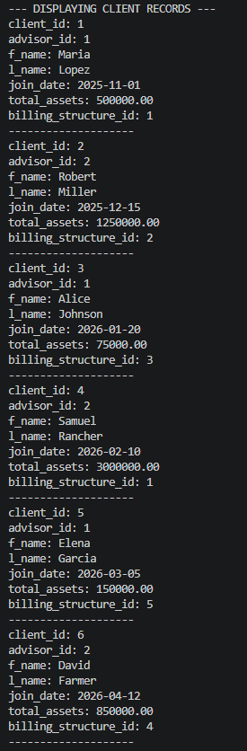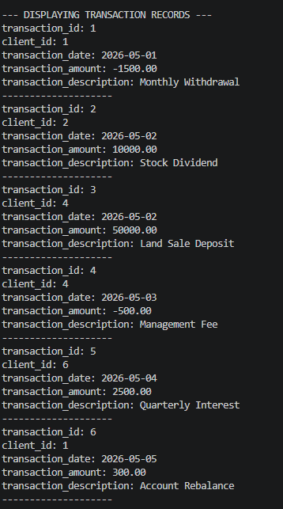
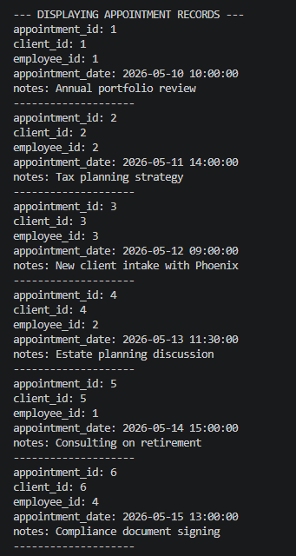

Milestone #3
Report 1: Monthly Client Growth
This report calculates the number of new clients added during each of the past six months. It allows the owners to visualize growth trends and assess the effectiveness of their business plan in attracting local ranchers, farmers, and retirees.
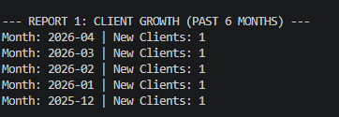
Report 2: Company-Wide Asset Overview
This report calculates the average amount of assets held by the entire client list. This information is critical for Jake and Ned to understand their current market position and decide if the existing billing structure is appropriate for the wealth level they are managing.

Report 3: High-Volume Transaction Clients
This report identifies clients who have more than 10 transactions in a single month. This helps the compliance manager and advisors monitor account activity and determine if high-volume users should be moved to a different billing structure to keep the business profitable.
